Calculating a structure factor
【Atkin’s “Physical Chemistry”, 8e, p.708, example20.3】
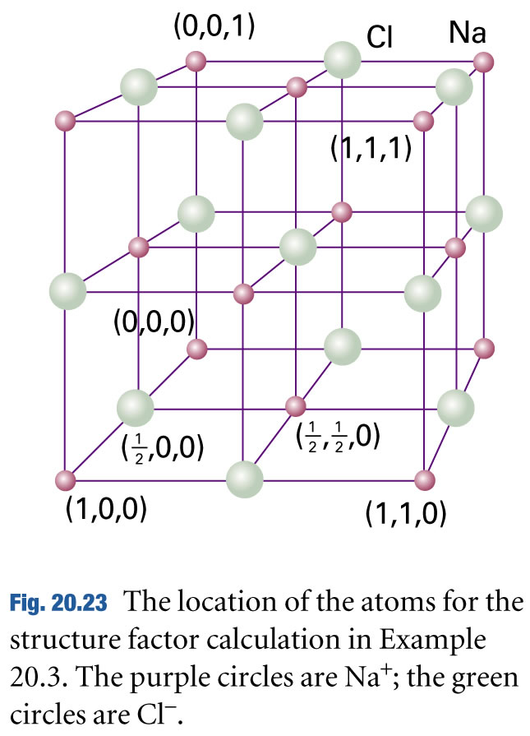

Na⁺ | (1/8) f⁺ |  |  | φ | e^{iφ} | Σ(1/8) f⁺ × e^{iφ}
Na⁺ | x | y | z | φ | e^{iφ} | Σ(1/8) f⁺ × e^{iφ}
Na⁺ | 0 | 0 | 0 | 0 | 1 | (1/8) f⁺ × 8 = f⁺
Na⁺ | 1 | 0 | 0 | 2πh | 1 | (1/8) f⁺ × 8 = f⁺
Na⁺ | 1 | 1 | 0 | 2π(h + k) | 1 | (1/8) f⁺ × 8 = f⁺
Na⁺ | 0 | 1 | 0 | 2πk | 1 | (1/8) f⁺ × 8 = f⁺
Na⁺ | 0 | 0 | 1 | 2πl | 1 | (1/8) f⁺ × 8 = f⁺
Na⁺ | 1 | 0 | 1 | 2π(h + l) | 1 | (1/8) f⁺ × 8 = f⁺
Na⁺ | 1 | 1 | 1 | 2π(h + k + l) | 1 | (1/8) f⁺ × 8 = f⁺
Na⁺ | 0 | 1 | 1 | 2π(k + l) | 1 | (1/8) f⁺ × 8 = f⁺
Na⁺ | (1/2) f⁺ |  |  | φ | e^{iφ} | Σ(1/2) f⁺ × e^{iφ}
Na⁺ | x | y | z | φ | e^{iφ} | Σ(1/2) f⁺ × e^{iφ}
Na⁺ | 1/2 | 0 | 1/2 | π(h + l) | cos(h + l)π | f⁺ × [ cos(h + l)π  + cos(h + k)π  + cos(k + l)π ]  = f⁺ × [ (-1)^{h + l}  + (-1)^{h + k}  + (-1)^{k + l} ]
Na⁺ | 1/2 | 1/2 | 0 | π(h + k) | cos(h + k)π
Na⁺ | 0 | 1/2 | 1/2 | π(k + l) | cos(k + l)π
Na⁺ | 1/2 | 1 | 1/2 | π(h + l) + 2πk | cos(h + l)π
Na⁺ | 1/2 | 1/2 | 1 | π(h + k) + 2πl | cos(h + k)π
Na⁺ | 1 | 1/2 | 1/2 | π(k + l) + 2πh | cos(k + l)π

Cl－ | (1/4) f－ |  |  | φ | e^{iφ} | Σ(1/4) f－ × e^{iφ}
Cl－ | x | y | z | φ | e^{iφ} | Σ(1/4) f－ × e^{iφ}
Cl－ | 1/2 | 0 | 0 | πh | coshπ | f－ × [ coshπ  + coskπ  + coslπ ]  = f－ × [ (-1)^{h}  + (-1)^{k}  + (-1)^{l} ]
Cl－ | 0 | 1/2 | 0 | πk | coskπ
Cl－ | 0 | 0 | 1/2 | πl | coslπ
Cl－ | 1/2 | 0 | 1 | πh + 2πl | coshπ
Cl－ | 1 | 0 | 1/2 | πl + 2πh | coslπ
Cl－ | 0 | 1 | 1/2 | πl + 2πk | coslπ
Cl－ | 0 | 1/2 | 1 | πk + 2πl | coskπ
Cl－ | 1 | 1/2 | 0 | πk + 2πh | coskπ
Cl－ | 1/2 | 1 | 0 | πh + 2πk | coshπ
Cl－ | 1 | 1 | 1/2 | πl + 2π(h + k) | coslπ
Cl－ | 1 | 1/2 | 1 | πk + 2π(h + l) | coskπ
Cl－ | 1/2 | 1 | 1 | πh + 2π(k + l) | coshπ
Cl－ | f－ |  |  | φ | e^{iφ} | Σf－ × e^{iφ}
Cl－ | x | y | z | φ | e^{iφ} | Σf－ × e^{iφ}
Cl－ | 1/2 | 1/2 | 1/2 | π(h + k + l) | cos(h + k + l)π | f－× (-1) ^{(h + k + l)}

F_{hkl} = f⁺ × [ 1 + (-1)^{h + l} + (-1)^{h + k} + (-1)^{k + l} ]
+ f－× [(-1) ^{(h + k + l)} + (-1)^{h} + (-1)^{k} + (-1)^{l} ]

